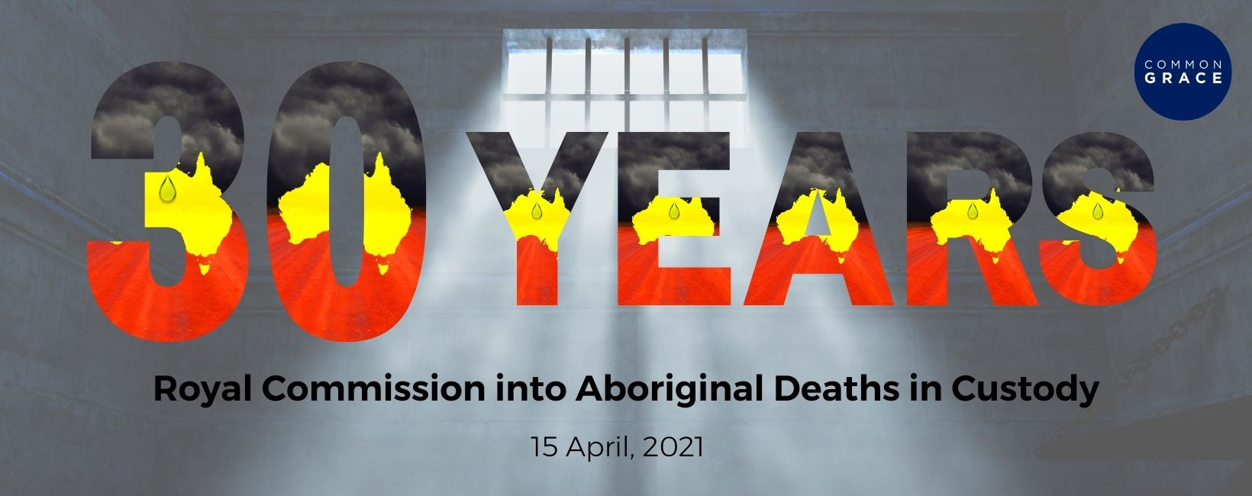
Dear friends.
Today marks 30 years since the Royal Commission into Aboriginal Deaths in Custody released its final report after investigating 99 Aboriginal Deaths in Custody between 1980-1989. 339 recommendations were made which are still valid today, but very few have been implemented.
In the last 30 years, 474 Aboriginal people have died in custody, 5 just in the past 6 weeks. Some of these deaths could have been prevented if the recommendations of the Royal Commission were implemented and adhered to. Many of the families have never received justice for their loved ones.
We must go beyond the numbers and respect and honour the individual lives lost. Today we honour the legacies of every Aboriginal person who has died in custody, we pray for their families and communities and thank God for their strength and courage to carry on the fight for justice.
As followers of Jesus, this is our fight too.
It says in Hebrews 13:1- 3, “Let mutual love continue. Do not neglect to show hospitality to strangers, for by doing that some have entertained angels without knowing it. Remember those who are in prison, as though you were in prison with them; those who are being tortured, as though you yourselves were being tortured.”
As Brooke says in her poem, “We Can’t Breathe”, “Just as these Aboriginal Deaths in Custody seem relentless, Through love - let our pursuit for justice be relentless!”
Our prayer is you will be the one today who will “Join us in justice, So it’s not just us.”
Take action today to #StopAboriginalDeathsInCustody and #StopBlackDeathsInCustody by:
- Watching Brooke’s poem “We Can’t Breathe” written in 2018
Watch the video on Facebook here
- Learning more about Aboriginal Deaths in Custody and learning the names and stories of the Aboriginal peoples who have died in custody.
The Aboriginal people Brooke names in her poem are:
Cameron Doomadgee (2004)
Mr Ward (2008)
Ms Dhu (2014)
Wayne Fella Morrison (2016)
David Dungay Jr (2018)

Access our Aboriginal Deaths in Custody resources here
- Praying
Access our Stolen Lives Prayer resources here
and our Aboriginal Deaths in Custody Prayer Vigil resources here
- Writing an email to the Minister for Police and Minister for Corrections in your State or Territory today, calling them to take action to #StopAboriginalDeathsInCustody
Access our template letter here

