Prepared by the Pacific Conference of Churches Secretariat
“Singing the Lord’s Song in Strange Lands and Times”
PACIFIC DAY OF PRAYER – 7th May, 2021
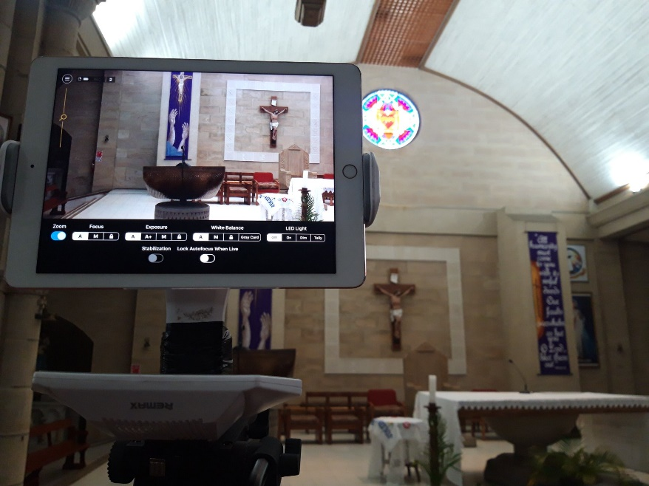
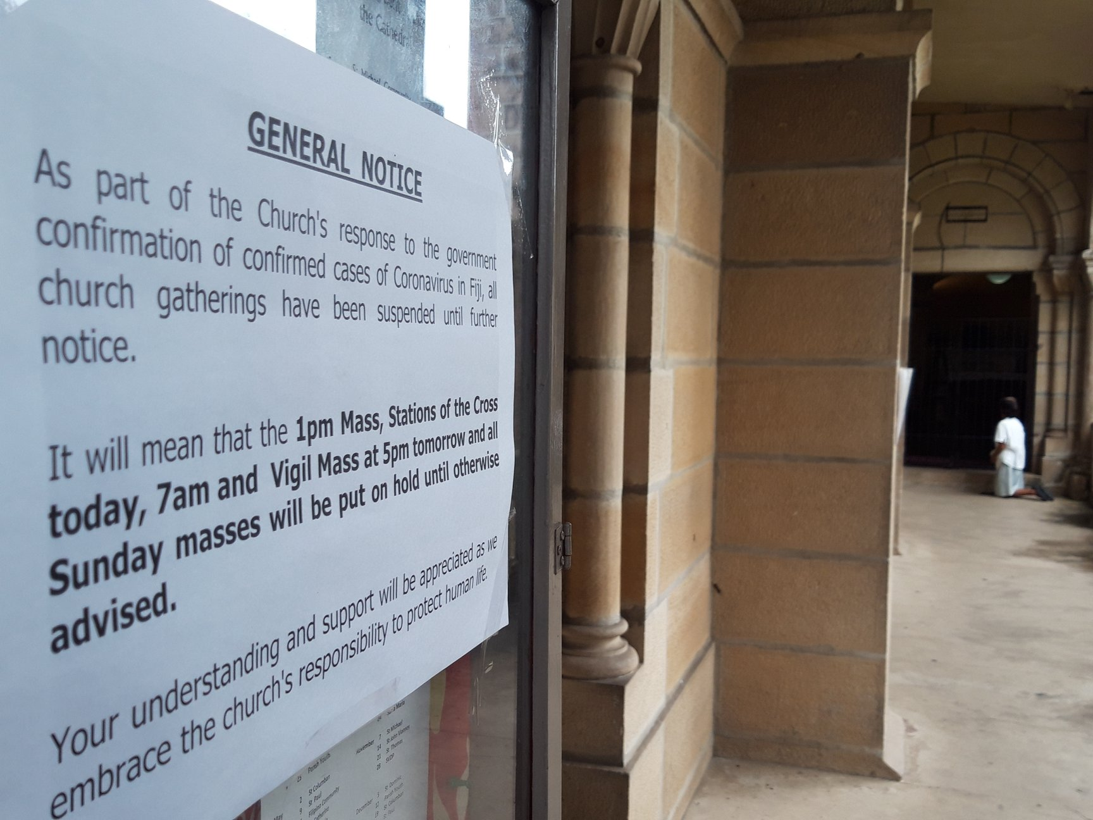
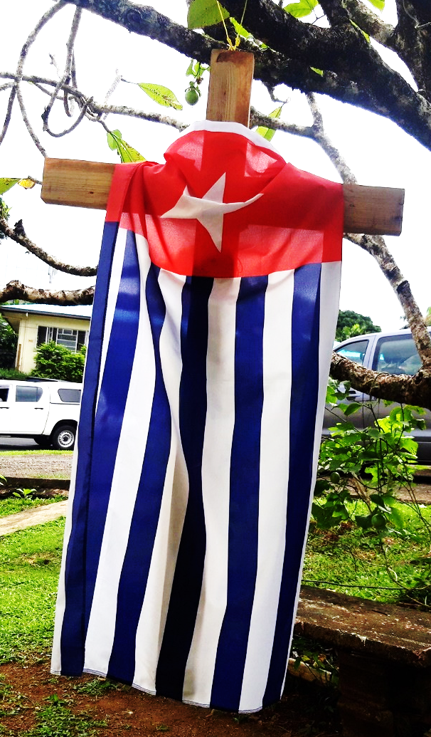

Contents:

- Introduction – Page 2

- Covid-19 in the Pacific – Page 3

- Remembering Pacific Leaders – Page 6

- Cry For Those Exiled In Their Own Land:
West Papuans Who Died Between 2019-2021 – Page 7

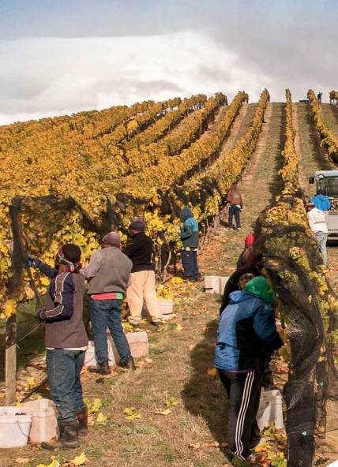
- Text: Psalm 137 – Page 9

- Bible Study 1 – Page 11

- Bible Study 2 – Page 15

- Suggested Liturgy for Pacific
Day of Prayer Service – Page 20

- Sermon Notes – Page 23

Introduction

Songs of Lament, Songs of Resistance, Songs of Hope

Warm Easter Greetings from the Pacific Conference of Churches Secretariat!

I apologise for the delay in this Pacific Day of Prayer Liturgy which this year, revisits the Theme for the 11th PCC General Assembly and is at the heart of our work from 2019 to 2023: “Singing the Lord’s Song in Strange Lands and Times”.

To say that these past 14 months have been difficult would be an understatement. This has been a major challenge for our Pacific people as also around the world, in a way that we have most likely not faced in the last 100 years. COVID-19 has shown our resilience in many ways. Amid sickness and death, unemployment, increased gender-based violence and socio-economic and political challenges, we have strengthened our spirituality, adapted our worship and drawn on our culture of sharing and caring as community and our indigenous knowledge to survive and help others in need.

Yet while the world’s focus is on COVID-19, in our region we continue to face the impacts of Climate Change – rising seas, ocean warming and acidification and extreme weather such as severe tropical cyclones. Lockdowns have been used to impinge due governance and democratic processes in some Pacific Island countries. Our sisters and brothers under the weight of colonial powers face not only economic, ecological and social oppression, their communities are at risk from COVID-19 because of decisions made by their colonizers. Under closed borders our seafares cannot return home, and while larger countries are not sending their citizens as tourists (thus compounding our economic challenges with the collapse of the tourism industry across the region), they are extracting our people as labourers under seasonal worker programmes and labour schemes to fulfil their needs. Under neo-colonialism and neo-liberal economics, extractive industries further desecrate our land and pillage our sea as many of our governments follow policies that lead us further into the foreign debt trap.

And so we cry our songs of lament, protest, hope and justice.

This year’s material includes some information on the impact of COVID-19 in our region, names of some our leaders who have died and the names of 16 West Papuans who were killed in the last 2 years by Indonesian Security forces.

I appeal to our member churches that we endeavour to make this not only a day of prayer observed by women’s fellowships but use this material throughout the church, whether on 7th of May as the first Friday in May, or during your annual conferences and synods or on another day this year.

God’s blessings and our love be with you all.
Rev. James Bhagwan,
General Secretary

COVID-19 in the Pacific

COVID 19 Statistics for the Pacific Region
Country | Total Reported Cases | Total Reported Deaths | Date
Cook Islands | 0 | 0 | 01/03/2021
Fiji | 66 | 2 | 12/03/2021
French Polynesia | 18,527 | 141 | 12/03/2021
Guam | 7,756 | 133 | 10/03/2021
Kiribati
Marshall Islands | 4 | 0 | 12/03/2021
Northern Mariana Islands | 153 | 2 | 15/03/2021
New Caledonia | 91 | 0 | 12/03/2021
Papua New Guinea | 5,184 | 45 | 29/03/2021
Solomon Islands | 18 | 0 | 12/03/2021
Vanuatu | 3 | 0 | 12/03/2021
Wallis and Futuna | 178 | 0 | 15/03/2021
Samoa | 3 | 0 | 12/03/2021
PACIFIC TOTAL: | 28,875 | 323 | 15/03/2021

Current statistics on COVID-19 in our region (taken from: Resources for the Global Week of Prayer to mark one year of COVID-19 pandemic: 22-27 March, 2021):
- Commonwealth of the Northern Marianas (CNMI): As of 15 March 2021, 154 confirmed cases of COVID-19 and 2 deaths were reported by CNMI. A total of 8 COVID-19 local cases have been identified in a community cluster between 12 and 14 March 2021. A red alert is added to the map. Source: CNMI COVID-19 Dashboard and CNMI Office of the Governor accessed on 15 March 2021.

- Fiji: As of 12 March 2021, 66 cases and 2 deaths have been reported in Fiji. There has been no new locally acquired case reported for more than two incubation period (28 days).– Source: Fiji Ministry of Health and Medical Services accessed on 15 March 2021.
- Maohi Nui: As of 12 March 2021, 18,527 cumulative cases and 141 deaths have been reported in French Polynesia. Locally acquired cases have been reported in the past 14 days. - Source: Direction de la sante accessed on 15 March 2021.

- Guam: As of 14 March 2021, 7,768 confirmed and probable cases and 133 deaths were reported by Guam Department of Public Health and Social Services (DPHSS). Locally acquired cases have been reported in the past 14 days. – Source : Guam Department of Public Health and Social Services accessed on 15 March 2021.

- Hawaii: As of 14 March 2021, 28,259 cases of COVID-19 and 451 deaths were reported by Hawaii Department of Health. Locally acquired cases have been reported in the past 14 days . – Source : State of Hawaii, Department of Health accessed on 15 March 2021.

- Kanaky: As of 14 March 2021, 93 COVID-19 cases (including 35 cases since 07 March 2021) have been reported by the New Caledonia Government. Locally acquired cases have been reported in the past 14 days.– Source: - Government of New Caledonia accessed on 15 March 2021.

- New Zealand: As of 15 March 2021, 2,430 confirmed and probable cases of COVID-19 and 26 deaths were reported by New Zealand Ministry of Health. There are currently no active cases in the community. No locally acquired case has been reported in the past 14 days. The red alert is changed to blue on the map. – Source : New Zealand Ministry of Health accessed on 15 March 2021.

- Papua New Guinea: As of 13 March 2021, there have been 2,173 confirmed cases and 21 deaths reported in PNG. Locally acquired cases have been reported in the past 14 days. – Source: Papua New Guinea COVID-19 accessed on 15 March 2021.

- Republic of Marshall Island (RMI): As of 03 March 2021, 4 imported cases have been reported by Ministry of Health and Human Service. There has been no locally acquired case reported. - Source:RMI Ministry of Health and Human Services facebook post, accessed on 15 March 2021.

- Samoa: As of 15 March 2021, 4 imported COVID-19 cases have been reported by the Samoan Government. There has been no locally acquired case reported. – Source: Samoa Government accessed on 15 March 2021.

- Solomon Islands: As of 15 March 2021, 18 imported cases have been confirmed by the Solomon Islands government. There has been no locally acquired case reported. – Source: Solomon Islands Government accessed on 15 March 2021.

- Vanuatu: As of 15 March 2021, 3 imported cases have been reported by the Vanuatu Government. There has been no locally acquired case reported. – Source: Ministry of Health, Vanuatu, accessed on 15 March 2021.

- Wallis and Futuna: As of 07 March 2021, 187 COVID-19 cases (including 178 cases since 06 March 2021) have been reported by the Wallis and Futuna Government. Locally acquired cases have been reported in the past 14 days. – Source: Préfet de Wallis-et-Futuna facebook post accessed on 15 March 2021

- West Papua - official information is not available however by November 2020 there were close to 12,000 confirmed cases. There are fears that these numbers are grossly under reported. According to Human Rights Watch - Greater Efforts Spent on Law Undermining Labor, Environmental Rights by the Indonesian Government.

How COVID – 19 has affected Our Region:

Pacific community in the Context of COVID-19:
- Struggling Health care systems that cannot handle increased COVID cases with shortages in supplies and space. Though most cases are in and around urban areas, health personnel are concerned about traffic and transmission out into the more rural areas of PNG.
- Tourism dependent Pacific economies now see a drastic drop in Gross Domestic Product due to travel restrictions. How will Pacific economies recover and hopefully adapt to changing economic climates?
- With COVID and the impact it has had on the tourism industry, Job loss and Unemployment have become a major concern for PIC’s. This has contributed to a number of social issues that stem from loss of income. These include:
  - Child Abuse and Sexual Exploitation
  - Unemployment and economic instability has led to concerns regarding increasing cases of Domestic violence and rape.
  - Mental Health and Suicide
  - Sex Trafficing and Prostitution
  - Influx in Squatter Settlement Population
  - Drugs, Alcohol and Substance Abuse
- Considering all these, there is also the challenge of coordinating a Pacific response to COVID 19 despite the threat to the Pacific Islands Regionalism in the PIFS debacle and Fiji’s relationship after deporting the former USP Vice Chancellor (Chiang 2021).

REMEMBERING PACIFIC LEADERS
Leaders who have died in the last year
Name | Age | Country | Date
Sir Michael Thomas Somare | 84 | Papua New Guinea | 26/02/2021
Paul Tovua | 73 | Solomon I(slands | 05//02/2021
Zhage Sil |  | West Papua | 24/12/2020
Ratu Tevita Momoedonu | 74 | Fiji | 26/11/2020
Jim Marurai | 73 | Cook Islands | 06/11/2020
Archbishop Allan Migi | 60 | Papua New Guinea | 22/10/2020
Pio Tabaiwalu | 60 | Fiji | 20/10/2020
Kuniwo Nakamura | 76 | Palau | 14/10/2020
Litokwa Tomeing | 80 | Marshall Islands | 12/10/2020
Archbishop Benedict To Varpin | 84 | Papua New Guinea | 08/09/2020
Nandi Glassie | 69 | Cook Islands | 04/09/2020
Joe Williams | 85 | Cook Islands | 04/092020
Tekii Lazaro | 66 | Cook Islands | 15/08/2020
Apisai Tora | 86 | Fiji | 10/08/2020
Sir Toke Tufukia Talagi | 51 | Niue | 15/07/2020
Giyannedra Prasad | 61 | Fiji | 1/06/2020
Raman Pratap Singh | 70 | Fiji | 18/05/2020
Froilan Tenorio | 80 | Northern Mariana | 04/05/2020
Laisenia Qarase | 79 | Fiji | 21/04/2020
Ratu Alifereti Finau Mara | 63 | Fiji | 15/04/2020
Satya Nandan | 84 | Fiji | 26/02/2020
Ken Joe Ada | 37 | Guam | 18/02/2020

CRY FOR THOSE EXILED IN THEIR OWN LAND: WEST PAPUANS WHO DIED BEWEEN 2019-2021
- NAME : FRED CHRISTIAN MAMBRASA
Age : N/A
Date/Place : 2 Februari 2021 in Port Moresby Hospital.
Status : A West Papuan activist in Port Moresby, PNG.

- NAME : HENGKY WAMANG
Age : 31
Date/Place :Timika, West Papua.
Status : A West Papua National Liberation Army (TPNPB) commander in Timika Area, Papua.

- NAME : REV. YEREMIA ZANAMBANI
Age : 68
Date/Place : 19 September 2020 in Hitadipa, Intan Jaya, Papua.
Status : Pastor at Evangelical Christian Church Indonesia (GKII).

- NAME : YULI S. YABANSABRA
Age : N/A
Date/Place : 21 August 2020 in Depapre, Jayapura, Papua.
Status : A young West Papuan lawyer in ELSAM Papua.

- NAME : MISPO GWIJANGE
Age : 16
Date/Place : 1 January 2021 in Wamena, Papua.
Status : Victim of Criminalization [Criminalized as member of West Papua National Liberation Army (TPNPB)].

- NAME : NELINCE BONSAPIA
Age : 63
Date/Place : 16 August 2020 in Biak Islands, Papua.
Status : Victim of Biak Massacre.

- NAME : THEYS MARTEN
Age : N/A
Date/Place : 13 November 2020 in Jayapura, Papua
Status : An Activist West Papua Student Solidarity National (SONAMAP) and West Papua National Authority (PNA).

- NAME : ETA LANNY
Age : N/A
Date/Place : 16 December 2020 in Expo Waena, Jayapura, Papua.
Status : Activist Forum Independent Mahasiswa (FIM).

- NAME : ALBERT PAHABOL
Age : 24
Date/Place : 16 January 2021 in Jayapura Hospital, Papua.
Status : Secretary General West Papuan Alliance (AMP).

- NAME : FERRY MARISAN
Age : 49
Date/Place : 6 July 2019 in Jayapura, Papua
Status : A West Papuan activist and former of ELSAM Papua Director in Jayapura, Papua.

- NAME : GANIUS WENDA
Age : N/A
Date/Place : 3 August 2020 in Jayapura Hospital, Papua.
Status : A young West Papuan lawyer, and member of West Papua Coalition Lawyer and Human Right Advocate.

- NAME : USKUP TIMIKA, JOHN PHILIP SAKLIL
Age : 59
Date/Place : 3 August 2019 in Timika, Papua.
Status : Pastor at Catholic Church in Timika, and advocate for indigenous West Papua people in Timika, and Meepago area.

- NAME : PASTOR JULIANUS BIDAU MOTE
Age : 51
Date/Place : 4 August 2019 at the Carolus hospital in Jayakarta, Indonesia.
Status : Pastor at Catholic Church in Jayapura.

- NAME : KRISTIANUS YANDUN
Age : 26
Date/Place : 27 Janury 2021 in Merauke, Papua.
Status : Activist at West Papua National Committee (KNPB).

- NAME : ENOS SEKENYAP
Age : 64
Date/Place : 16 March 2019 in Kurima, Yahukimo, Papua.
Status : Member of Papuan Customary Council (DAP), Laapago area in Kurima.

- NAME : ANIS M. WANIMBO
Age : 31
Date/Place : 27 December 2020 in Honelama, Wamena, Papua.
Status : Deputy Chairman West Papua National Committee (KNPB) Balim Barat / Area

Text: Psalm 137
New Revised Standard Version (NRSV) | The Message (MSG)
Psalm 137  Lament over the Destruction of Jerusalem  ¹ By the rivers of Babylon—  there we sat down and there we wept  when we remembered Zion.  ² On the willows^{[a]} there  we hung up our harps.  ³ For there our captors  asked us for songs,  and our tormentors asked for mirth, saying,  “Sing us one of the songs of Zion!”  ⁴ How could we sing the Lord’s song  in a foreign land?  ⁵ If I forget you, O Jerusalem,  let my right hand wither!  ⁶ Let my tongue cling to the roof of my mouth,  if I do not remember you,  if I do not set Jerusalem  above my highest joy.  ⁷ Remember, O Lord, against the Edomites  the day of Jerusalem’s fall,  how they said, “Tear it down! Tear it down!  Down to its foundations!”  ⁸ O daughter Babylon, you devastator!^{[b]}  Happy shall they be who pay you back  what you have done to us!  ⁹ Happy shall they be who take your little ones  and dash them against the rock!  Footnotes  - Psalm 137:2 Or poplars  - Psalm 137:8 Or you who are devastated | 137  ¹⁻³ Alongside Babylon’s rivers  we sat on the banks; we cried and cried,  remembering the good old days in Zion.  Alongside the quaking aspens  we stacked our unplayed harps;  That’s where our captors demanded songs,  sarcastic and mocking:  “Sing us a happy Zion song!”  ⁴⁻⁶ Oh, how could we ever sing God’s song  in this wasteland?  If I ever forget you, Jerusalem,  let my fingers wither and fall off like leaves.  Let my tongue swell and turn black  if I fail to remember you,  If I fail, O dear Jerusalem,  to honor you as my greatest.  ⁷⁻⁹ God, remember those Edomites,  and remember the ruin of Jerusalem,  That day they yelled out,  “Wreck it, smash it to bits!”  And you, Babylonians—ravagers!  A reward to whoever gets back at you  for all you’ve done to us;  Yes, a reward to the one who grabs your babies  and smashes their heads on the rocks!
The Complete Jewish Bible (CJB) | Good News Translation (GNT)
137  By the rivers of Bavel we sat down and wept  as we remembered Tziyon.  ² We had hung up our lyres  on the willows that were there,  ³ when those who had taken us captive  asked us to sing them a song;  our tormentors demanded joy from us —  “Sing us one of the songs from Tziyon!”  ⁴ How can we sing a song about Adonai  here on foreign soil?  ⁵ If I forget you, Yerushalayim,  may my right hand wither away!  ⁶ May my tongue stick to the roof of my mouth  if I fail to remember you,  if I fail to count Yerushalayim  the greatest of all my joys.  ⁷ Remember, Adonai, against the people of Edom  the day of Yerushalayim’s fall,  how they cried, “Tear it down! Tear it down!  Raze it to the ground!”  ⁸ Daughter of Bavel, you will be destroyed!  A blessing on anyone who pays you back  for the way you treated us!  ⁹ A blessing on anyone who seizes your babies  and smashes them against a rock! | A Lament of Israelites in Exile  137  By the rivers of Babylon we sat down;  there we wept when we remembered Zion.  ² On the willows near by  we hung up our harps.  ³ Those who captured us told us to sing;  they told us to entertain them:  “Sing us a song about Zion.”  ⁴ How can we sing a song to the Lord  in a foreign land?  ⁵ May I never be able to play the harp again  if I forget you, Jerusalem!  ⁶ May I never be able to sing again  if I do not remember you,  if I do not think of you as my greatest joy!  ⁷ Remember, Lord, what the Edomites did  the day Jerusalem was captured.  Remember how they kept saying,  “Tear it down to the ground!”  ⁸ Babylon, you will be destroyed.  Happy are those who pay you back  for what you have done to us—  ⁹ who take your babies  and smash them against a rock.

Psalm 137 Bible Study One

Setting:
This psalm is set in the Babylonian Exile.
• Psalm 137 is located in a situation of displacement, loss and trauma; the ideas it shares need to be read within that context.
- It opens with a group of exiled Judeans sitting by the rivers of Babylon (their new home; an empire), weeping and remembering Zion (their former home; destroyed and gone). What causes them to weep is not clear; perhaps the memories of what once was. Memories can be painful! Why need to remember at all?

- It closes with a call for violence against Babylonian babies/children (infanticide). A discomforting call that is rooted on a need for revenge, o first, against Edomites who not only failed to help them in times of suffering, but also called for sexual violation (i.e. “strip her, strip her to her very foundations”), second, against Babylonians for their brutality and barbarity, especially when they destroyed Jerusalem.
  - Memories of such events can be violent and can cause violence!
  - But why do babies/children have to suffer for the sins of their parents? How might we deal with such violent texts?

- Between the opening and ending, lies the following:
  - Exiles retreating from making music (lyres hung up)
  - Exiles refusing to sing (despite being asked to sing by their oppressors)

- Note, the request is for a song of Zion (attached to a place, perhaps to mock them); the answer, a song of the Lord (attached to a person).

Does this imply that every song of Zion is the Lord’s song? If so, are they only allowed to be sung in the Lord’s land, and not anywhere else? But isn’t the Lord’s land now owned by the Babylonians?

The central question: How can we sing a song of the LORD on alien soil?
- Which/whose song is the Lord’s?
- Isn’t Zion an alien soil as well?
- Exiles pledge not to forget Zion
- What is Zion to the exiles? A home?
- What is home?
- Is it a place? Is it an imagined space?
- Is home a fixed, immobile place?

Psalm 137: Bible Study One continued

The overarching orientation of the psalm is to remind the readers the significance of Zion/Jerusalem as their homeland. Yet, this is far from the being the only exilic voice in the Bible.

Read Jeremiah 29:4-7 (NJPS):
4Thus said the LORD of Hosts, the God of Israel, to the whole community which I exiled from Jerusalem to Babylon:
5 “Build houses and live in them, plant gardens and eat their fruit.
6 Take wives and beget sons and daughters; and take wives for your sons, and give your daughters to husbands, that they may bear sons and daughters. Multiply there, do not decrease.
7 And seek the welfare of the city to which I have exiled you and pray to the LORD in its behalf; for in its prosperity you shall prosper.”

- Whereas in Psalm 137 the call is for exclusion, non-conformity and violence, Jeremiah 29 urges immersion, integration, and co-existence.
- Whereas Psalm 137 puts emphasis on the memory of Zion, their homeland, Jeremiah 29 encourages the building of new homes in their new host-land regardless of what happened.
- Whereas in Psalm 137, home is a place to remember and return to, home in Jeremiah 29 is something you negotiate on the move, and not a place of return.

So, what are the implications of these two biblical positions on exile and home for Pacific migrants in various places, and for Pacific migrant churches in particular?
What might be our position on migrants and refugees—those who seek to find shelter
amongst us in our midst?

Migration is our story
The story of humanity is one of movement and migration; we are all migrants!
That is who we are! We constantly participate in the ongoing cycle of departure, travel and arrival. And we never settle!
Once we arrive, we depart! That’s what makes life exciting!
The stories recorded in the Bible are migrant stories—of people seeking refuge, of people looking for a new life, of people exploring new possibilities, of people seeking new opportunities, of people venturing into the unknown for its own sake, of people being forced to move, of people whose only
option is to escape from slavery, violence and oppression, and so forth.

Amongst these people is a Migrant God whom we find in their midst—a God who moves with them, wanders with them, crosses boundaries with them, confronts oppression with them, breaks traditions of death with them, shares bread of life with them, dwells with the least of them, resists
hegemonies amongst them, endures hardships with them, and ultimately dies and lives for them!

That’s what a Migrant God looks like! So, should be migrant churches!

Memory is our link
Migration is the condition for memory.
We yearn to remember because we shift and move constantly, and as such, we are
linked to places, peoples, and events by our memories. Psalm 137 repeatedly mentions memory and remembrance with reference to Zion, Jerusalem and God. Israel is called upon to remember who they are not only as chosen people, but also as former slaves delivered by God.

Memories however differ from one person/group to another. Our ability to remember is not the same. Sometimes we have selective memory: remember only that which we choose to remember. And not all memories are pleasant; some needs to be ignored, otherwise it will cause more than
harm than good.

Memory is not a perfect reconstruction of the past; at best we have distorted memories. As such, whatever we recreate/clone will also be imperfect. Memory can be violent and vengeful (Psalm 137:9). Cf. exile & holocaust
Most churches are holding on to memo ries of places, ideas, etc., that belong to a bygone era and as such unable to embrace what is new, relevant and life-affirming. Our memories need checking!

Violence is not ok!
Violence is prevalence in religions and in sacred texts, including the Church and the Bible. The current #MeToo movement against sexual violence exposes the barbarity of the issue and the complicity of churches, Christian leaders and their sacred texts.

To go along with texts that call for stripping and bashing of women and children, like Psalm 137, is to commit violence in the name of God and religion, and that is totally unacceptable. Violence of any kind must be resisted, and any violent-supportive systems (like patriarchy and empire) must be demolished.

o How might we as members of Pacific churches respond to this issue of violence in
our midst?
o How safe is our Church spaces for our children, women and those who are vulnerable to such acts of violence?
o How might we weave ourselves together in a way that respects and promotes the dignity and humanity of those subjugated by oppressive systems like patriarchy?

The challenge for Pacific churches both inside and outside our islands is to envision a future that is life-giving for us all. Such a future begins with the courage to move beyond the borders of our own ethnic, cultural and denominational boundaries. It involves empowering people to speak truth to power, speak the truth about power, and strive for justice, equality and fullness of life. That is the Lord’s song, and that is the song worth-singing wherever we are!

QUESTIONS FOR REFLECTION, DISCUSSION AND SHARING:

1. In what way did, being forced to stay at home and the stopping of church services, as a result of COVID-19 induced lockdowns lead you to feel to a sense of exile, by not be able to “sing the Lord’s song” (worship) in your own land?

2. Short-term migrant workers (seasonal workers picking fruit, domestic workers, caregivers, seafarers etc) from our region can experience a sense of exile, particularly when cut off from community and family, in isolated areas, being treated unjustly and with expectations of money being sent back to their families (remittances). This is exacerbated by closed borders where some workers find themselves cut off for months. How might churches in sending countries (where these workers come from) and receiving countries (where they work) not only help them to sing the Lord’s song but listen and meaningfully respond to the lament and hope expressed in their singing?

3. What systems of exploitation can you see in your community/country where people may feel like an alien in their own land?

4. In this study, 2 biblical positions – exile and home are shared. In the context of climate-induced migration, where people may need to relocate within an island state or where people from one island state may need to relocate to another country, how might the church and Pacific Christians ensure that these relocations are not dislocating exile experiences but as finding a new homeland?

Bible Study Two
Ps 137 is read as an epic psalm which combines songs of struggle which originated within the golah (exile)community in Babylon and were reborn during the post-exilic period within the Yehud community when the golah community returned. Therefore, Ps 137 is an anthology of struggle songs which engage issues of imperial power and domination by capturing the anxieties of the exilic period and the post-exilic period.

Singing the Lord’s Song as a Song of Decolonisation
Ps 137 should be viewed as an epic "song of struggle" in that it brings shorter songs together, which are politically charged. The epic nature of the songs is manifested not so much in the length of the song in its final form as in its weaving together songs of struggle into one song of struggle.

A song of struggle or liberation song is politically motivated, and it is intended to advance a political cause with reference to historical events. During oppression, colonialism, exile, people use songs, on the one hand, as a healing balm for dealing with the hellish day-to-day experience of a violent system and, on the other hand, as a weapon in the struggle for instilling the ideology of the struggle in the consciousness of people, to mobilise and express political dissent.
Struggle songs promoted unity and endurance among the oppressed people as they (the oppressed) addressed directly and frankly the unjust treatment by the oppressive system. Through struggle songs, the oppressed denounce the oppressor or oppressive state by mentioning names of state representatives. Yet other struggle songs were addressed not to the oppressor, but to the stalwarts of the liberation movement as a deliberate strategy to encourage the leaders of the movement. Struggle songs may be viewed as their own separate category or genre; within this genre, however, sub-genres may also be identified.

Ps137, unlike many other psalms which do not reflect their historicity, unequivocally points to the historical setting that it is reflecting on-the Babylonian exile period. In the case of the Ps 137, some scholars have observed that this psalm contains different elements: lament, a song of Zion, and a curse / call for vengeance. Ps 137 may be viewed as a collection of three struggle songs in which can be heard the "voices of exile" filled with the pain of exile. Ps 137 is that it is composed of three struggle songs which originated within the golah community during the exilic period in Babyon.
In terms of the arrangement of the psalm, scholars generally agree that it has a three-fold division:

Stanza 1: Ps 137:1-4
Stanza 2: Ps 137:5-6
Stanza 3: Ps 137:7-9

Psalm 137:1-4: Song of Protest
From a decolonial perspective, Ps 137:1-4 is more than a mere song about the plight which those in the struggle faced; rather, it is a politically charged song which was intended to motivate the oppressed to defy the oppressive forces. The request by the captors (שׁוֹבֵינוּ) / tormentors (שְׁׁאֵלוּנוּ) is not to be viewed as an innocent request out of curiosity by the Babylonians considering the dynamics at play between the coloniser and the colonised. Rather, the oppressed do not view the request as innocent, and the language they use is telling.

Indeed, some interpreters regard the request (or the plea or the demand) of the captors/tormentors as a mockery of the exiles, and considering the dynamics at play between colonisers and the colonised, the request for a song from the captured (the exiled Judaean / golah community) should be viewed as an act of censorship by the oppressor amounting to control of what could be sung and not sung.

The lyrics of protest songs can threaten the state, or endanger 'the whole fabric of society'.

The request for "songs of Zion" by the captors/tormentors should be viewed as a request for folk songs which would not challenge or threaten the empire. The songs of Zion would thus have been songs which have nothing to do with the current realities which the golah community faced in Babylon. The request for songs of Zion was in all likelihood because the captors were suspicious of the songs that the golah community was singing.

The struggle songs during the exilic period in all likelihood would have run contrary to the ideological position held by the pro-Babylonians back in the land and among the exiles who opted for submission. The pro-Babylonian elements would have served the agenda of the oppressor, preaching assimilation (Jer 29:5-7) and warning of the dangers of not assimilating (Jer 29:8).

The pro-Babylonian ideology was a version of reality not accepted by all the exiles.
The question "How can we sing the songs of YHWH while in a foreign land?" is indicative of the trauma of exile. The golah community sat or dwelled by streams of water, indicative of the potential for it to thrive within the domain of the capturer, yet for the psalmist, the situation did not evoke emotions of joy, as it was not in Zion. This is in contrast to the pro-Babylonian ideology, which pictured the exiles' condition as one of the tolerable conditions.

Psalm 137:1-4 likely reflects the social condition of the first wave of exiles of 597 BCE.40 Thus, the first wave of displaced people at the streams of Babylon was to serve the captors by engaging in hard labour at irrigation canals. These immigrants continually wept when they recalled their own land, which they left not voluntarily but forcibly, and furthermore that they now had to face the prospects of losing their identity, culture, and language.

This protest song, thus, comes as a response to the forced immigration and the hard labour at Babylon's canals, coupled with the longing to return to the land; it also comes as defiance against the censure from the captors to quell revolution that could be sparked through struggle songs. Attempts to flee from exile or fight back cannot be excluded from the picture - as some from the golah community would have attempted to resist their enslavement through attempts to fight back or escape. The book of Daniel seems to recall instances of religious protests in which the protesters were prepared to die, and it is highly likely that similar standoffs would have also occurred by the canals where the exiles would have been labouring while singing the slave songs as weapons of their struggle.

The Jews 'show their defiance to the captor not by refusing to sing, but by what they sing,' they 'fill a recognizable form with an unexpected content.' They wanted to lay aside their harps; but now they are compelled to sing, so they take comfort in this song of national pride. In the temple, the Lord's song comes out as praise; but in exile, everything is inverted, and it comes out as anger.

Psalm 137:5-6: A Song of Sorrow
In the case of Ps 137:5-6, it is a song of a people who could not challenge the Babylonian empire militarily or through violence to bring about meaningful change. The first wave of exiled Yehudites would have been well aware of the failed attempts to regain power by Zedekiah and Ishmael. In his/her sorrow, the psalmist makes a vow not to "forget" Jerusalem and invokes on the self, a curse - right-hand paresis and loss of speech, which would imply a loss of ability to sing and play a musical instrument.

In the context of Ps 137:5-6, the remembrance of Jerusalem evokes the motif of freedom, reverse immigration, or a new exodus. The exaltation of Jerusalem in v. 6b ("If I do not set Jerusalem above the greatest of my joy") cannot be set in the past; it is rather a future hope. The new exodus would not be to a "strange land" but a return to the psalmist's own land, which would be a fulfilment of his/her joy. In the context of the song, the exile moment is a moment of sorrow, and the time of joy is still in the future.

Psalm 137:7-9: A Song of Revenge/War
The theme of remembrance continues in this section of the psalm, there is, however, a significant shift. It is not the oppressed people who are called to remember in this case; rather, it is the God of the oppressed people who is called by them to remember their enemies, Edom and Babylon. The remembrance, in this case, does not carry any positive sentiments. The oppressed do not prescribe the form of judgment that should be meted out against Edom, but they do prescribe the form of judgment that should be meted against Babylon. This section of the psalm or this song is a song of revenge or war.

The violence that is wished on the enemies, particularly Babylon, is of the worst possible evil -their babies are to be captured and smashed against stones.
The violence that is wished on Babylon is not "new and unheard-of evil"; rather, it was common in ancient warfare. In similar instances, the atrocity of dashing children is coupled with the killing of unborn babies by killing pregnant mothers or ripping them open (Isa 13:16; Hos 10:1315; 13:16/14:1; cf. 2 Kgs 15:16; Amos 1:13).54 The motif of death or killing of children also evokes the exodus motifs. In the exodus story, the Egyptians sought to disempower the Hebrews by killing the Hebrew baby boys at birth (Exod 1:1617), and on the reverse, the act that finally led to the eventual release from Egypt was the killing of every firstborn in Egypt, human and animal (Exod 13:15). The extreme violence wished on Babylon in decolonial terms reflects the imperial non-ethical conduct of war, which included among other things rape, the ripping open of pregnant women, the killing of new-borns, torture, mutilation, genocide, destruction of property and sacred places, enslavement, capture and deportation.

Inasmuch as the modern reader may take offence at the horrendous violence that the oppressed wished for their mockers and oppressors, it cannot be erased or explained away. This is a song against the oppressor.

It is very likely that this portion of the psalm originated during the exilic period following the events of 587 BCE as an expression of the vengeance the writer desired on the enemies. The psalmist's call has to be viewed as a call for a form of retributive justice, a counterbalancing act to be meted out against the oppressor. However, it is worthy to note that when the Persian empire overthrew the Babylonian empire, it did not occur with the kind of violence called for in this song. This as a key indication that this song reflects the exilic environment.

Thus, while freedom can be negotiated peacefully, it is not always possible. The colonial-apartheid system of domination had as its mode of operation exploitation, oppression, and violence.

Colonialism is violence in its natural state and it will only yield when confronted with greater violence. The policeman and the soldier, by their immediate presence and the frequent and direct action, maintain contact with the native and advise him by means of rifle butts and napalm not to budge. It is obvious here that the government speaks the language of pure force. The intermediary does not lighten the oppression: he shows them up and puts them into practice with a clear conscience of an upholder of peace: yet he is the bringer of violence into the home and into the mind of the native.

Underlying the struggle songs was the demand for freedom and decolonial justice.
Decolonial justice has as its preferential option the damned, that is, the oppressed/colonised.

Modern colonialism, has radicalised and naturalised the non-ethics of war by rendering the conquered as inferior and therefore condemning the conquered to a position of slavery and the day-to-day hell of "killability" and "rapeability.

However, the hope of the future lies with the damned, the wretched of the earth, when they become agents of transformation. They have the potential of transforming the modern/colonial into a transmodern world: that is a world where war does not become the norm or the rule, but the exception.

Decolonial justice is not the trading of one oppressor with another, where the previously oppressed become the new oppressors; rather, it is the demand of a just society in which colonial structures of domination and oppression of the other are undone.

In the context of Ps 137:7-9, the damned, the oppressed Yehudites, could not engineer the overthrow of the empire from below; they had to rely on the possibility that another imperial power would overthrow Babylon and hopefully secure their freedom. However, their view of attaining freedom through another form of imperial violence perpetuates the naturalisation of war in which the conquered are killable and so their babies. Decolonial justice does not preclude the use of violence to attain freedom, yet the goal is to denormalise and denaturalise the non-ethics of war.

QUESTIONS FOR REFLECTION, DISCUSSION AND SHARING:

- Are our songs only those of worship and praise? Do we lament and call for God’s justice and express our hope in our songs?

- To what extent might our choice of hymns and acceptance of contemporary songs and acts of worship display be seen as censorship and control? How might we decolonise our worship in a respectful way?

- What can we do, as members of the Pacific Household of God, to amplify and join the chorus of the laments and cries for justice, peace and self-determination in West Papua, Ma’ohi Nui and Kanaky?

- Are there communities in your society that may also be singing in this way?

Suggested Liturgy for Pacific Day of Prayer Service

- Call to Worship:
In the name of the Spirit of God, who hovered over the primordial waters.
In the name of the Word of God, who called forth creation.
In the name of the Wisdom of God, who filled the created the amazing designs that form the delicate web of life.
Eternal God, the whole cosmos sings of Your glory, from the dividing of a single cell to the vast expanse of interstellar space:
Creator God,
God of the waitui, the moana, the solwara – the oceans, turquoise lagoons within the reef and the depths of dark blue sea
God of the lagilagi – the sky, the atmosphere and outer space
God of the vanua, the fenua – the land and all that is within it:
You created this world with the power of Your word.
You formed humankind with Your own hands and breathed Your own breath into us.
You gave us these lands as a gift – a source of our identity and sustenance.
You empowered us to be the stewards of what you have made.
Oceans, seas and watery deep, celebrate with all that lives within You, and roar in praise with us today.
We celebrate the song of Oceania; the Liquid Continent
As the reef heron stretches its wings rises over the waves, our prayers rise to You.
We give thanks for the sea, for fish, turtle, dolphin and coral; for creatures of the land and the sky.
Our spirit seeks You in the early dawn, O God, for your commandments are light.
We worship You.
In the name of the Risen One
Jesus the Christ, AMEN

- Welcome and introduction

- Hymn or Act of Worship

- Prayer of Confession
We confess to You, O Lord, that we have persevered in our sinfulness,
We admit to You, O creator of the universe, that we have corrupted Your creation,
We confess to You, Lord of the universe, that we have forgotten Your commandments,
We confess to You, Loving Father, that we have offended Your love,
We confess to You, O Most Merciful, that we did not show mercy to each other,
We admit to You, who are Able, that we were not able to curb our greed,
We confess to You, Redeemer, that we did not respect Your redemption,
We put Your gifts to ruin,
We destroyed the natural environment You endowed us with!
We destroyed the life You created!
We destroyed the creation that You redeemed!

In the midst of our tumultuous daily life, we forgot the distinctio between good and evil, between truth and falsehood, and between truthfulness and blasphemy, and we hid behind masks that we borrowed from Your legacy and falsified them to meet our interests.

We forgot in our gasping behind the vainglories that Your trust in us has a right, so we created a society of consumption, prevented protecting the environment. We established injustice as a rule of life and deceitfulness as a guide to dealing with each other, and when we reached the end of times, we accused You of punishing us.
Because evil is so widespread in our togetherness, we forgot that You are the Lord of love, and thought that we are in the presence of the Lord of punishment that our minds invented! We have forgotten that we do not fear the Lord, but rather we love Him, and the good deeds that we do are not due to fear but spurred by identification with His boundless love which we seek to incarnate.

Because of the intensity of our ignorance, we thought that the pandemic that was about to destroy humanity was a punishment inflicted by You, and we forgot that we were the ones who produced it from our excessive darkness.
As we gather here to pray for the end of this pandemic, we are inspired by You and we admonish to ourselves and to each other, invoking Your boundless mercy.
From eternity to everlasting times, we will not forget that You redeemed us and sacrificed Yourself for us, so make us worthy of Your redemption and make us preserve the gifts that You have bestowed upon us.
In Jesus’ name we pray, AMEN

- The Lord’s Prayer, if not said elsewhere, may be said here.

- Hymn or Act of Worship

- Bible Reading: Psalm 137 and John 15: 9-17

- Sermon: “Singing Songs of God’s Love in Difficult Times”

- Prayer of Intercession
O Lord our God,
Source of all goodness and love.
We pour out our hearts to You.
We ask that You may deliver us from a world without justice and a future without mercy; in your mercy establish justice, and in Your justice, remember the mercy revealed to us through Your Son.

Dear Lord, we ask that You draw near and comfort our brothers and sisters in West Papua. We pray that You will guide them on their journey to self-determination and to protect them over the violence they face daily.
We ask that You awaken our praise and thankfulness for every being that You have made. Give us the grace to feel profoundly joined to everything that is. show us our place in this world as channels of Your love for all the creatures of this earth, for not one of them is forgotten in your sight. Enlighten those who possess power and money that they may avoid the sin of indifference, that they may love the common good, advance the weak, and care for this world in which we live.

Loving God, You ha e never failed to show Your power and caring by healing people of all ages and stations of life from physical, mental, and spiritual ailments. Be present now to people who need Your loving touch because of COVID-19. May they feel Your power of healing through the care of doctors and nurses. Take away the fear, anxiety, and feelings of isolation from people receiving treatment or under quarantine. Give them a sense of purpose in pursuing health and protecting others from exposure to the disease. Protect their families and friends and bring peace to all who love them.

Heavenly Father, who sees the unseen and notices the unnoticed, help each of us to hear the Hidden Voices of those who pray for release from slavery and exploitation, who suffer the horrors of modern slavery, for all who dream of a better life in another place, only to be trapped, tricked and traded, for all those who labour, forced and unseen, to make our everyday possessions, for all who agonise for loved ones lost into this trade in humans.
Help us in our weakness not to seek to oppress others, nor to make peace with any form of exploitation, so that we may give ourselves more fully to the service of your saving love, and be strengthened together as agents of your healing and hope,

God of Justice and Peace, we pray for a world torn apart by conflict and war. A world that lives uneasily in a climate of fear with no clear vision for future days. We pray for a world clear of corruption, we remember the poor, the homeless and those who are stuck within spaces that are toxic or violent. We ask that You help them to find a place that is safe and free of suffering, where they are free from the pain that they currently face. We pray for our churches that it may always be a safe space for our people, we pray for the ministers and the work that they do; may You guide them on their journey of help. We also pray for our congregations; may they do their duty as Christians to create spaces within their own circles that is inclusive of all people and nature.

This is our prayer in Jesus’ name. AMEN

- Hymn

- Final Prayer and Benediction
Loving and embracing God,
We have come together as members of God’s Pacific Household,
As members of the Body of Christ,
As fellow disciples, voyagers of the way of Christ our Mast and Master,
Strengthen us in our common work with our sisters and brothers around our islands and oceans for Your Kingdom.
May God the Father, who called us from darkness into light, make us true bearers of God’s light.
May God the Son, who redeemed us by his precious blood, empower us to follow his example in serving others.
May God the Holy Spirit, who is Lord and giver of life, strengthen us to endure the shipwrecks of life and reach the shores of salvation.
May the Almighty and Merciful God, Father, Son and Holy Spirit, bless and protect us now and forever. AMEN.
Sermon Notes:

The Gospel Reading is the common lectionary reading for this Sunday and part of the “True Vine” discourse. Having just taught his disciples that they are connected to him and to each other as branches on the vine, Jesus now deepens the relationship. He preaches the importance of love, the centrality of love, and the interconnectedness that comes about as a result of love. He has proved his love by his death, and his love provides not just the example but also the very foundation for love among his followers.

In verse 9, he reminds them of the Father's love for his Son, which is the model of his love for his disciples:
"As the Father loves me, so I also love you."

We remain in his love by keeping his commandments, just as Jesus keeps his Father's commands. Christian love is traced to the Father as its source. It is expressed in the redemption of Jesus and then in the mission of all his followers who are to love one another as God loves us. This passage also points to the upward direction of obedience. Jesus' response to the love of the Father is lived out in his obedience to the Father's commands. Likewise, Jesus' followers are to respond to his love through obedience to his commands.

To make the point dramatically clear, to teach unmistakably what it means to love, Jesus reminds them of the ultimate sign of love: "No one has greater love than this, to lay down one's life for one's friends" (15:13).

Thus, love is more than a feeling. Love is action. Jesus' standard of perfection makes that perfectly clear.

In John 8:31-33, Jesus has taught the disciples about the transition from being a slave to being free.

Slaves do not belong to the family perma-nently; they will be set free by the truth that he brings. Thus, he will no longer call his disciples slaves. He has taught them what the father taught him. Unlike slaves, they know what the master is doing. They are now friends, rather than slaves. This reading ends with a same straightforward imperative, to "Love one another" (15:17).

Love as radical solidarity.
Liberating relationships.

These two key messages from the Gospel speak to the colonised community of Psalm 137 in Babylon, experiencing exile and oppression.

During the early part of our lockdowns many of our sisters and brothers in Christ, so used to communal worship and life, asked how to sing the Lord’s song in a strange land. How to worship God amid closed churches, social distancing, and isolation. How to experience the eucharist only spiritually during televised or livestreamed mass and worship. How to sing the Lord’s song in the aftermath of disasters?

In his bible study at the PCC 11th Assembly in 2018 in Auckland, Rev. Dr. Nasili Vaka’uta shared that while the Babylonian’s request is for a song of Zion (attached to a place, perhaps to mock them), the answer, a song of the Lord. He then asked delegates if this implied that every song of Zion is the Lord’s song? If so, are they only allowed to be sung in the Lord’s land, and not anywhere else? What would it mean if the Lord’s land now owned by the Babylonians?

In 2013, the Pacific Church Leaders attending the World Council of Churches in Busan, South Korea, performed what was an act of love as radical solidarity. Invited onto the performance stage following an encore performance by the Pacific Youth from member churches, they made space for the representatives from the GKI Tanah Papua Church to not only join them but sing their constitutionally guaranteed but prohibited anthem “Papua Land”, which West Papuans could only sing in their homeland at great risk because that land is occupied by Indonesia.

The second bible study, looked at the psalm from the view of the exiles as a colonised people and the psalm as made up of three songs – one of protest (how can we sing the Lord’s song?); one of sorrow/lament (Jerusalem, if I forget you…) and one of revenge or retribution as a result of their oppression.

West Papuans continue to face racism, discrimination and oppression in their homeland, while their soul, the land is extracted for profit for others and they continue to struggle.

The most recent Pastoral Letter from the West Papuan Council of Churches highlights this:
- 2,603 security forces deployed in the last 2 years.
- 480 civilians killed in clashes between the security forces TPNPB and 34,461 internally displaced people in the Nduga Regency between December 2018 and March this year.
- 10 people including 2 church workers, 1 person with disability and 1 student killed and 1,000 displaced internally in Intan Jaya.
- Systemic (structural) racism, violations of civil and political rights.
- Influx of 1,470,000 Indonesian migrants over a decade to keep indigenous Papuans as a minority.
- Widescale deforestation for palm oil plantations, mineral extraction and even Elon Musk’s rocket launch site, with no free, prior and informed consent of customary landowners.

How do we as their sisters and brothers in Christ practice radical solidarity? How are we able to echo their protests, laments and cries for justice and liberation, for self-determination? As they call for the UN Human Rights Commission to investigate human rights abuses in Papua, for real political dialogue and engagement – how do we share their song, sing their song to our leaders?

Likewise with those who find themselves in a state of exile of through migrant labour, either as seafarers, seasonal or labour scheme workers, which is heightened or exacerbated by COVID-19 lockdowns and border closures. Our region has experienced slavery to South America, and modern slavery in the form of blackbirding Solomon Islanders and Ni-Vanuatu to Australia and Fiji, indentured labour from India and China into the Pacific in our region.

At the core of this crime is deception. Survivors of modern slavery tell stories of being sold a better life. They are often vulnerable, coming from areas where there is little possibility of work. They are oﬀered a job, a chance to make money and to build a new life for themselves.

The job they are oﬀered turns out to be a lie and instead they are forced to work in diﬃcult and degrading conditions, with little or no pay. The threat of violence, to themselves or their families, hangs over them and traps them in their situation. Even if their traﬃcker does not physically control them, a mistrust of authority, shame and embarrassment may stop them seeking help. `

This is the reality for 15,000 men, women and children in Australia and 3000 in New Zealand.

For the Pacific Island States the high risk industries are fisheries, construction, agriculture, hospitality and domestic services.

As the Global Freedom Network points out:
Today many citizens of Pacific Island states look to improve their circumstances by seeking work in larger regional economies, accessing work opportunities in industries like agriculture, fisheries, tourism and hospitality.

They remain however vulnerable to subcontractors and agents, who sometimes take advantage and exploit their isolation and lack of knowledge. The conditions for migrant and seasonal workers are a growing pastoral concern for Pacific Island diaspora communities who hear reports of harsh employment conditions, and allegations of mistreatment.

Some of these conditions would fall under the category of modern slavery and forced labour.

Those who try to escape difficult situations are treated as absconders and penalised by both sending and receiving, and in the case of sending governments, penalised the communities of these workers, without investigating the reasons and possibility of neglect, mistreatment and other breaches of working conditions by the employer.

The cultural shame and psychological impact of being punished for escaping negative conditions drives people underground and causes problems for all.

In this context what are the ways we as church can ensure liberating and loving relationships for migrant workers from our communities that go overseas, and also for migrant workers who find themselves in our own communities?

How do we hear the songs of lament? How do we respond?

Adapted from a Bible Study presented by Rev. Dr. Nāsili Vaka'uta, (Principal & Ranston Lecturer in Biblical Studies, Trinity Methodist Theological College / Te Haahi Weteriana o Aotearoa) at the 11th General Assembly of the Pacific Conference of Churches, in Auckland, Aotearoa, on Monday 29th October, 2018
Source: “Song(s) of Struggle: A Decolonial Reading of Psalm 137 in Light of South Africa's Struggle Songs,” Hulisani Ramantswana, University of South Africa, Old testam. essays vol.32 n.2 Pretoria, 2019. http://dx.doi.org/10.17159/2312-3621/2019/v32n2a12
Yehud is the Aramaic version of ‘Judah’ (Hebrew Yehudah). In the Persian empire, where Aramaic was the common language of the western part of the empire, it was the name of the administrative province succeeding to some, but by no means all, of the former territory of the kingdom of Judah. In recent scholarly work it has become common to refer to Judah by this name when dealing with the Persian period (539-323 BCE), just as it is called Judaea in reference to the Roman period.

