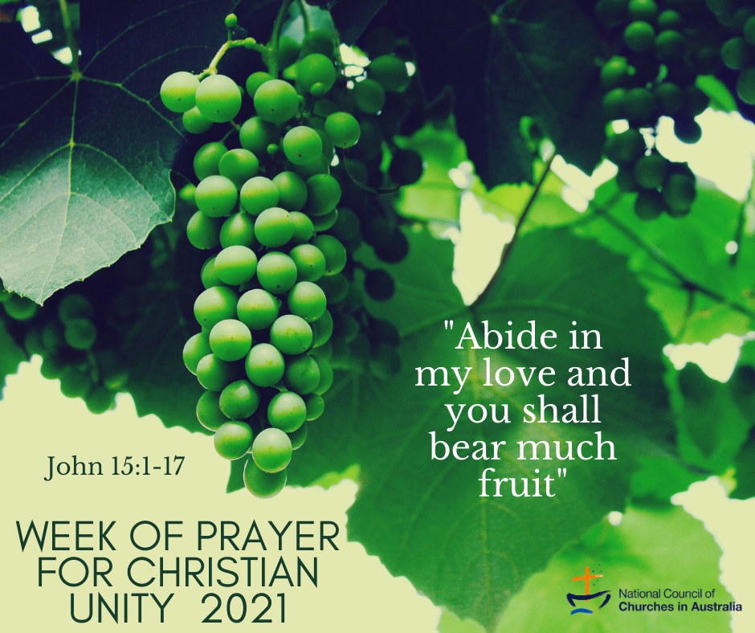


Preparation and Introduction

This celebration reflects the ways in which the sisters of Grandchamp pray. In this tradition three of the monastic prayer services – sometimes called ‘vigils’ or ‘nocturns’ in the Benedictine tradition – traditionally said during the night are combined into one evening service. In the same way, our service for the Week of Prayer for Christian Unity reflects this structure.
Each vigil follows the same pattern: readings from scripture; a sung response; a time of silence; and intercessions. Each vigil also has an action reflecting its theme; these are outlined below. Each concludes with the singing of Light of God (Lumière de Dieu), composed by a member of the community of Grandchamp.
The first vigil is centred on the unity of the whole person and our abiding in Christ. The large (possibly Easter) candle will be lit. Silence is a key part of the prayer. Moments of silence are repeated throughout the service.
The second vigil expresses the desire to rediscover the visible unity of Christians. Anchored in the love of Christ, we turn to our neighbours and exchange with each other a sign of his peace.
The third vigil opens us up to the unity of all peoples, all creation. The action in it is inspired by a text of Dorotheus of Gaza (see introduction). Representatives from each church community come and form a circle around the candle – the light of Christ. They will take their candles that are lit from the Christ candle to share with the rest of the assembly.

It is suggested that:
- Each person in the congregation will need to have an unlit candle.
- A large, raised candle (for example the Easter candle in many traditions) is set as the central point of a circle. This is positioned in an open space where people can gather.
- When invited, six to eight people from different Christian traditions come forward and form a circle around the candle.
- Each of these people carries a small unlit candle raised high so all can see.
- At the end of the reading, each person in the circle moves to the centre and lights his/her candle.
- During the singing they take their light and share it with the assembly
- Everyone holds their lighted candle through to the Dismissal. In some places, where it is appropriate and practicable, the congregations may process out of the place of worship with candles lit

The litany at the beginning can be read or sung – if possible, by two different people. The psalms can also be read or sung, or replaced by a hymn related to the theme of the vigil. The responses during the prayers of intercession can be read, sung or replaced by others. The intercessions can be prolonged by adding time for free prayer. Musical settings of the litany, responses and intercessions used at Grandchamp can be found later in this Order of Service.

Hymns can be accessed and heard on the website of the Community of Grandchamp: www.grandchamp.org.

You can also listen to their common prayer online every day at: www.grandchamp.org/prier-avec-nous

Order of the Celebration

“Abide in my love and you will bear much fruit”

(Cf. John 15:5-9)

L: Leader
C: Congregation
R: Reader

Invitation to Prayer

Entrance Hymn
A hymn invoking the Holy Spirit (to be chosen locally)

Word of Welcome

L May the grace of the Lord Jesus Christ, the love of God and the communion of the Holy Spirit be with you always!
C And also with you.
R1 Sisters and Brothers in Christ, this year the theme of the Week of Prayer for Christian Unity, chosen by the sisters of the Community of Grandchamp in Switzerland, is: “Abide in my love and you shall bear much fruit”. Since the time of its preparation, the community has been directly affected by COVID 19. As we begin our prayer we remember this community and the many millions of people throughout the world who have suffered or succumbed to this pandemic.
R2 It is the great desire of God, expressed by Jesus, that we might come to him and abide in him, especially in the midst of suffering. He waits for us tirelessly, hoping that, united to him in love, we will find solace and produce fruit that will bring life to all. Faced with the difference of ‘the stranger’, we risk withdrawing into ourselves and see only that which separates us. But let us listen to the way Christ invites us to abide in his love, and so to bear much fruit.
R1 In the three moments of prayer that follow, we remember the call of Christ, we turn to his love, to him who is the centre of our life. For the path of unity and love begins with our intimate relationship with God. Abiding in his love strengthens the desire to seek unity and reconciliation with others. God opens us up to those who are different from us, those who are suffering, those who need our love. This is an important fruit, a gift of healing for the divisions within us, between us, and in the world.
The Christ candle is lit in silence by a designated person.
L In peace let us pray to the Lord:
God, you are the vinedresser who cares for us with love.
You call on us to see the beauty of each branch united to the vine,
the beauty of each person.
And yet, too often the differences, the pains and struggle in others make us afraid.
We withdraw into ourselves.
Our trust in you is forsaken.
Come and direct our hearts toward you once again.
Grant us to live from your forgiveness
so that we may be together and praise your name.

Litany of praise
C You who call us to be praise in the midst of the earth: glory to you!

R1 We sing your praise in the midst of the world and among all peoples,
R2 We sing your praise in the midst of creation and among all creatures.

C You who call us to be praise in the midst of the earth: glory to you!
R1 We sing your praise among suffering and tears,
R2 We sing your praise among promises and achievements.

C You who call us to be praise in the midst of the earth: glory to you!

R1 We sing your praise in the places of conflict and misunderstanding;
R2 We sing your praise in the places of encounter and reconciliation.

C You who call us to be praise in the midst of the earth: glory to you!

R1 We sing your praise in the midst of rifts and divisions,
R2 We sing your praise in the midst of life and death, the birth of a new heaven and a new earth.

C You who call us to be praise in the midst of the earth: glory to you!

First Vigil: Abiding in Christ – The Unity of the Whole Person

Psalm: 103
Reading: Jn 15:1-17
Response: Ubi caritas
Short silence

Intercessions
R God of love, through Christ you said to us: “You did not choose me but I chose you”. You seek us, you invite us to receive your friendship and abide in it. Teach us to respond more deeply to this invitation, and grow in a life that is ever more complete.
C The joy of our heart is in God. (see sung version)
R God of life, you call us to be praise in the midst of the uncertainties of this world and to welcome one another as a gift of your grace. May your loving gaze, which rests upon each person, open us to receive each other just as we are.
C The joy of our heart is in God.
R God who gathers, you knit us together as one vine in your Son Jesus. May your loving Spirit abide in us at parish meetings and local ecumenical gatherings. Grant that together we might celebrate you with joy.
C The joy of our heart is in God.
R God of the one vineyard, you call us to abide in your love in all we do and say. Touched by your goodness, grant us to be a reflection of that love in our homes and workplaces. May we pave the way for bridging rivalries and overcoming tensions.
C The joy of our heart is in God.

Action: Longer silence

R Very often we think of prayer as something we do, an activity of our own. In this short time we are invited to an interior silence, and to turn aside from all the noise and concerns of our lives and thoughts. In this silence the action belongs to God. We are simply called to abide in God’s love, to rest in him.
Silence
Hymn: Lumière de Dieu (Light of God) [see additional material at end of this service]

Second Vigil – The Visible Unity of Christians
Psalm: 85
Reading: 1 Cor 1:10-13a
Response: There is One Lord, One Faith, One Baptism [see additional material at end of this service]
Short silence

Intercessions
R Holy Spirit, you create and re-create the church in all places. Come and whisper in our hearts the prayer which Jesus addressed to his Father on the eve of his passion: “that they may all be one … so that the world may believe”.
C Kyrie eleison (Lord have mercy)
R Lord Jesus, Prince of Peace, light the fire of your love in us so that suspicions, contempt and misunderstanding cease in the church, even more so in this time of uncertainty due to the pandemic and other natural disasters. May the walls that separate us fall.
C Kyrie eleison (Lord have mercy)
R Holy Spirit, Consoler of all, open our hearts to forgiveness and reconciliation and bring us back from our wanderings.
C Kyrie eleison (Lord have mercy)
R Lord Jesus, gentle and humble of heart, give us poverty of spirit so that we may welcome the unexpectedness of your grace.
C Kyrie eleison (Lord have mercy)
R Holy Spirit, you never abandon the men, women and children in so many countries around the world who are persecuted for their fidelity to the gospel. Give them strength and courage, and support those who help them.
C Kyrie eleison (Lord have mercy)

Action: Sharing a Sign of Peace
R The Lord calls us to be united among ourselves. He gives us his peace and invites us to share it. Let us exchange a sign of his peace with our neighbours.
Everyone turns to those near them and offers a sign of peace, in keeping with their local context (and pandemic requirements).
Hymn: Lumière de Dieu (Light of God)

Third Vigil – The Unity of all peoples and all creation

Psalm: 96
Reading: Rev. 7: 9-12
Response: O you who are beyond all things [or other suitable sung response]
Optional homily
Short silence

Intercessions
R God of life, you have created every human being in your image and likeness. We sing your praise for the gift of our many cultures, expressions of faith, traditions and ethnicities. Grant us the courage always to stand against injustice and hatred based on race, class, gender, religion, and fear of those who are different from ourselves.
C God of peace, God of love, in you is our hope!
R Merciful God, you have shown us in Christ that we are one in you. Teach us to use this gift in the world so that believers of all faiths in every country may be able to listen to each other and live in peace.
C God of peace, God of love, in you is our hope!
R O Jesus, you came into the world and shared fully in our humanity. You know the hardships of life for people who have suffered physically, emotionally and economically, as a result of the pandemic. May the Spirit of compassion move us to share our time, life and goods with all those in need.
C God of peace, God of love, in you is our hope!
R Holy Spirit, you hear the fury of your wounded creation and the cries of those already suffering from climate change, including our neighbours in the Pacific. Guide us toward new behaviours. May we learn to live in harmony as part of your creation.
C God of peace, God of love, in you is our hope!

Action: Moving to the centre… and out to the world
R We are called to be ministers of God’s healing and reconciling love. This work can only be fruitful when we abide in God, as branches of the true vine which is Jesus Christ. As we come closer to the light of Christ we draw closer to one another.

The designated persons are invited to come forward and form a circle around the Christ candle.

R When people living in this world, desire to draw closer to God, each walks toward the light. As they move closer to the light of Christ they also move closer to each other.

When the candle-bearers reach the centre they each light their candle. As they stand together at the centre all keep a time of prayer in silence.

Short Silence

The silence is broken with the Hymn: Lumière de Dieu (Light of God)

During the singing the candle-bearers return and share with the congregation the light that they have received.

R When we abide in Christ, we receive the Spirit of courage and wisdom to act against all injustice and oppression. We say together:

C Pray and work that God may reign.
Throughout your day
let the Word of God breathe life into work and rest.
Maintain inner silence in all things so as to dwell in Christ.
Be filled with the spirit of the Beatitudes: joy, simplicity, mercy.

(These words are recited daily by the Sisters of the Grandchamp Community.)

The Lord’s Prayer
L With the words that Jesus taught us, let us now pray in confidence together:
C Our Father…

Blessing
L Be one, so that the world may believe! Abide in his love, go out from this place and bear the fruits of this love.

C May the God of hope fill us all with joy and peace in faith, so that we may abound in hope by the power of the Holy Spirit. In the name of the Father, the Son and the Holy Spirit. Amen.

Final hymn (to be chosen locally)

ADDITIONAL MATERIAL

Lumière de Dieu (Light of God)

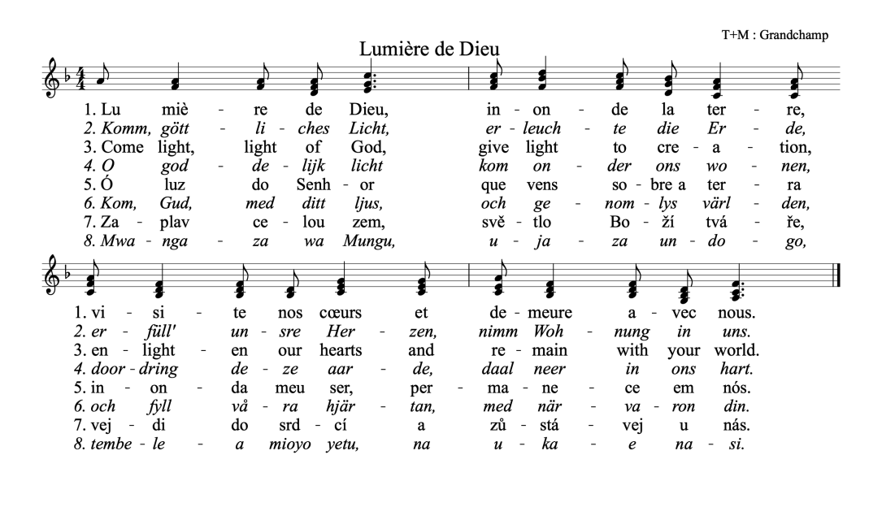

There is One Lord, One Faith, One Baptism

