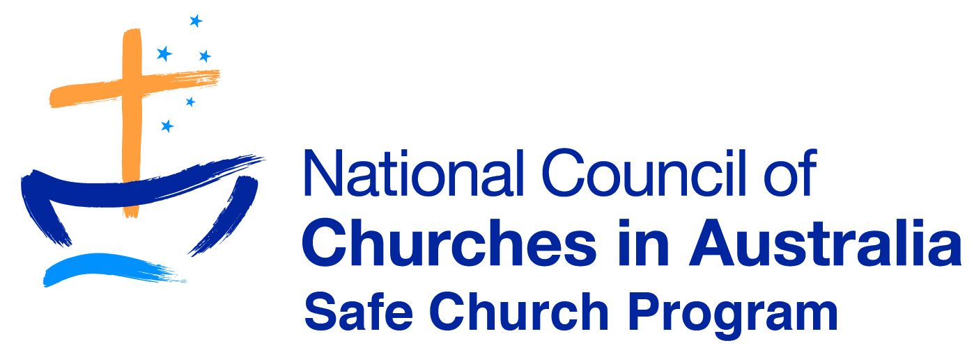
Safe Church Presenter- Application Form

Name
Address
Email
Phone
Date of Application

- Be recommended for endorsement by the Professional Standards Unit, Safe Church Unit, or Senior Church Leadership (please include name and title)

- Have experience in facilitating youth , have presented before or facilitated adult learning groups (please outline your experience or number of workshops)

- Have relevant industry experience (e.g. Church Leadership, Child Protection, and Social Work etc.).

- Have attended an SCTA workshop as a participant within the last 3 years: Y/N

- Agree to being supervised by an SCTA endorsed presenter & accept feedback: Y/N

- Have a current WWCC or equivalent (depending on your state): Y/N

- Can provide a current police check: Y/N

- Desirable-Have completed a Certificate IV in Training and Assessment (TAE 40110), or have a higher professional qualification or equivalent workplace experience

