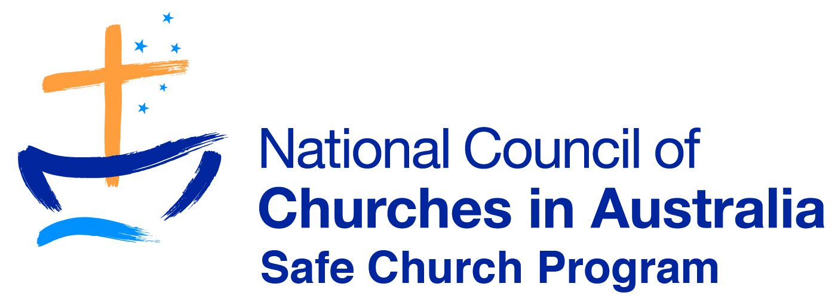

The current National Council of Churches in Australia (NCCA) Safe Church Training Agreement (SCTA) endorsed presenter training recruitment process has been developed to ensure the highest quality presenters are selcted to run Safe Church Awareness workshops.

To apply, please address the following criteria in the application form attached:
- Be recommended for endorsement by the Professional Standards Unit, Safe Church Unit, or Senior Church Leadership
- Have experience in facilitating youth or adult learning groups or run SCTA workshops
- Have relevant industry experience (e.g. Church Leadership, Child Protection, and Social Work etc.)
- Have attended an SCTA workshop as a participant within the last 3 years
- Agree to being supervised by an SCTA endorsed presenter and accept feedback
- Demonstrate an understanding and interest in running SCTA workshops ecumenically
- Have a current WWCC or equivalent (depending on your state)
- Can provide a current police check
- Desirable-Have completed a Certificate IV in Training and Assessment (TAE 40110), or have a higher professional qualification or equivalent workplace experience

An endorsed presenter will:
- Understand the SCTA National Standards
- Understand the SCTA workshop and resource materials
- Understand legislated and recommended reporting procedures
- Understand the relevant State, Territory and Federal legislation and keep up to date
- Understand the Church diocese/synod or organisation’s policies on protection, safety and care of children and vulnerable people
- Can clearly present workshop/training information, effectively lead discussions and answer questions appropriately
- Has capacity to explore and challenge values and manage resistance in workshop sessions
- Be willing and able to travel and present workshops regularly
- Manage the technical and practical requirements of setting up workshop resources and equipment (tables, chairs, data projector, laptops etc.)
- Collect and review workshop registrations and feedback forms and be able to return these electronically to the SCTA contact person
- Work as part of a team
- Be proficient in Microsoft PowerPoint and XL and be able to communicate easily via email
- Maintain regular contact with the SCTA National Coordinator about progress and provide an annual written response about the experience i.e. highlights ,challenges and theological reflection

Thank you for your interest in becoming an endorsed SCTA presenter in this vital ministry for the NCCA in our churches in Australia.

Laura Cregan-National Coordinator

