Message from the General Secretary

PARIS AND WORLDWIDE TERRORISM
The tragic events in Paris on Friday 13th have filled our media, our conversations, our thinking. The dreadful events in the French capital as well as in Beirut and Baghdad have engendered all kinds of thoughts and feelings in us. Fear, loathing, dread, hatred… The trouble with these feelings is that they can so easily be misdirected. Our responses can very easily be irrational.
People have gathered in solidarity with the people of Paris. On Sunday France’s flag flew beside the Australian flag on Sydney Harbour Bridge, and the tricolour was visible across buildings around Australia.
Enormous challenges face governments the world over. Somehow, individually and communally, we are called to respond. Christians and people of faith have responded in prayer, #PrayforParis.
The words of the prayer of St Francis suggest a response:
Lord, make me an instrument of your peace, where there is hatred, let me sow love; where there is injury, pardon; … where there is despair, hope; … The prayer continues: Grant that I may not so much seek to be consoled as to consoled; to be understood as to understand…
At this time, these words encourage me to seek to understand … to listen... to learn … to respond in friendship … to those who are at risk of being labelled as ‘enemy’.
On Sunday the Anglican Archbishop of Sydney led a prayer service in St Andrew’s Cathedral for those who died in Paris. More than 500 people attended. Civic leaders from NSW and representatives of the French Government were present.
On Monday evening, the Catholic Archbishop of Sydney celebrated a memorial service in St Mary’s Cathedral for those who died in the terror attacks. I was able to be present. The Cathedral was full. I presume that there were many Catholics. Besides state dignitaries and diplomatic personnel, members of other Christian churches were present. This was not surprising. What did surprise me was seeing a number of people of other faiths: Jews, Buddhists and Muslims. I was moved by their presence. It seemed to me that their presence expressed not only their sorrow for the people of France but also witnessed to their longing for peace and understanding in our land.
May we continue to find new ways of expressing our unity and solidarity.
DEATH AND DYING
Last month I reflected on obituaries. In the past ten days or so, death and dying have been in my thinking. Andrew Denton has appeared in media promoting changes in legislation in support of euthanasia. Within the past week, a friend, a middle-aged woman, wife and mother, told me that she had recently been diagnosed with an aggressive form of cancer; In the same week we heard of the birth of Daphne Siva’s granddaughter. As a colleague commented at the time of Daphne’s death, she lived with cancer. Daphne’s faith and peace right up to the time of her death spoke loudly of this time as being special.
My prayer for those including my friend who is facing death is that they will live with the same hope and peace as Daphne and that death – whenever it comes – will be a special and sacred time for them and those whom they love.
As Christians, as believers in Jesus Christ who gave his life in love, we are called to express our belief and our hope. Dying, death, and our belief in the resurrection of Christ are all part of the one mystery. May our faith speak more loudly than the increasing number of media messages.
ARMENIAN GENOCIDE CENTENARY COMMEMORATION
On Sunday 8 November the Armenian community in Australia celebrated a two-fold event in Beauchamp Park, Chatswood. His Grace Bishop Haigazoun Najarian unveiled and blessed a Memorial Khackar (Cross-Stone) dedicated to the commemoration of the Armenian Genocide Centenary. The sculptor, Varaztad Hambardzumyan, had done most of the work in Armenia, and came to Australia in late October to add the finishing touches. This most beautiful and intricate cross stands in the corner of the park.
Khachkar is the prayer of our ancestors,
Offering by the language of the stone,
Khachkar is our face, our destiny,
The pathway of our crossing and the glance of our soul to God.
The occasion also marked the official launch of the sister cities agreement between Willoughby City and Nor Nork in Armenia.
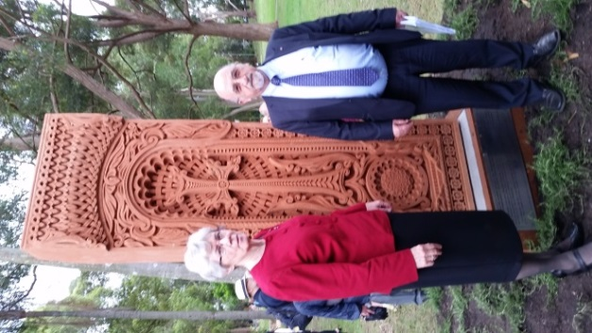
INDIAN ORTHODOX CHURCH
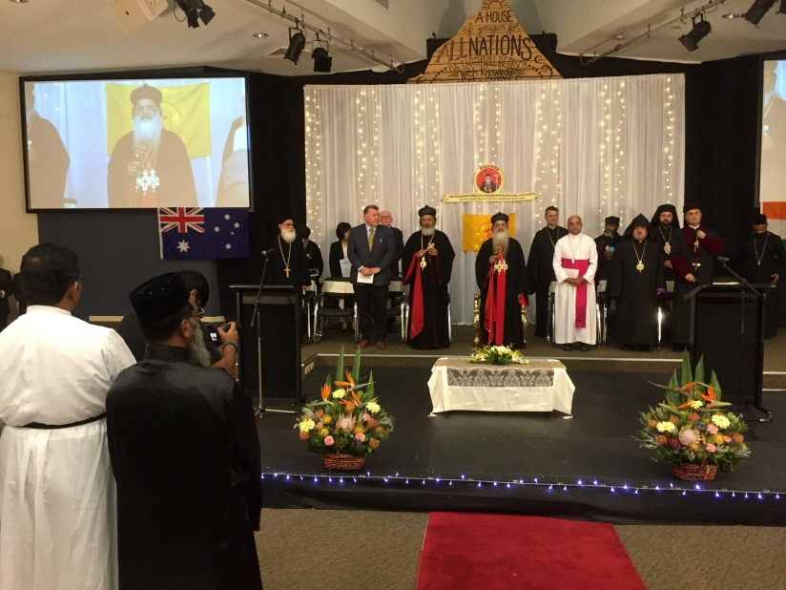
Ob Saturday 14 November, the Indian Orthodox Church (Malankara Orthodox Syrian Church) welcomed to Australia His Holiness Baselios MarThoma Paulose II and His Grace Dr Yuhanon Mar Dioscoros, their diocesan bishop. It was a great joy to welcome His Holiness along with a number of Heads of Churches or their representatives.
The reception for His Holiness showed me how important it is for a faith community to express their faith in the tradition in which they have grown.
It is just ten years since the church of St Thomas was consecrated as a cathedral; in fact it is a mere 25 years since the People of the Indian Orthodox tradition came together with the intention of supporting each other in their faith. Reflecting on this fact, and having been present with the community at St Thomas earlier in the year, meeting the people, seeing their buildings, enjoying their warm hospitality, I could only marvel and give thanks for how they have grown as a living faith community.
POSITION VACANT Executive Officer, Palestine Israel Ecumenical Network
The Palestine Israel Ecumenical Network (PIEN) is a group of Australian Christians who seek lasting peace for Palestine and Israel. PIEN is looking for an Executive Officer, 12hrs per week, based anywhere in Australia, to commence in February 2016. The role is to support the network to: build relationships; inform and equip Churches and Christians; and to engage in campaigns. We are looking for someone with excellent communication skills who enjoys working ecumenically, has a strong commitment to social justice and capacity to initiate educational and advocacy initiatives. For more information see www.pien.org.au or contact Rev Gregor Henderson, PIEN co-convener, at gregorhenderson@aol.com or 0418 770 622. Applications close 11th December 2015.
Participants at the Australian Ecumenical Officers Network (AEON) meeting in Melbourne recently (L to R): Fr Shenouda Mansour (NSW); Rev’d Ian Smith (Vic); Rev’d Richard Turtin (Qld); Ms Geraldine Hawkes (SA); Sr Elizabeth (NCCA); Frederick Mul (Tas). |  |  | 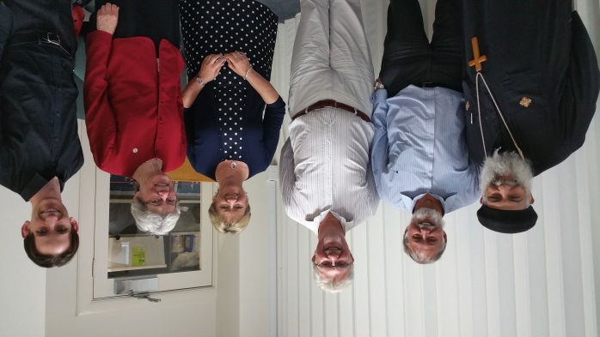
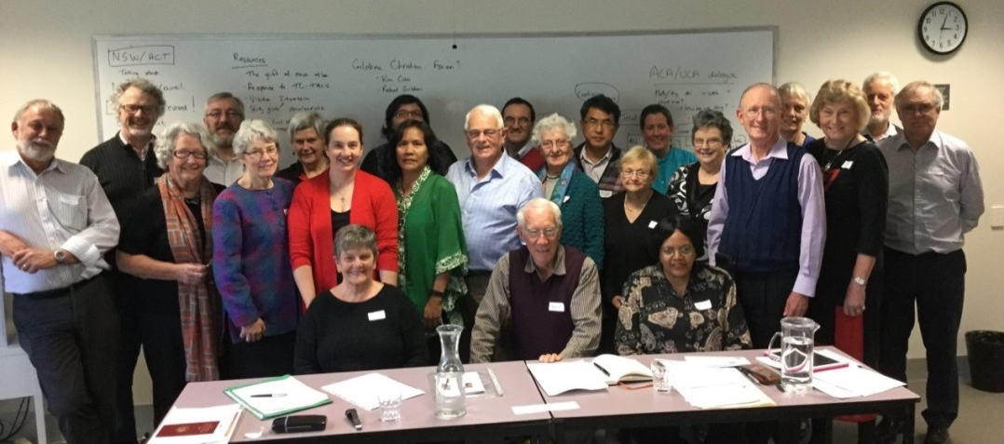 |  |  |  |  | Sr Elizabeth (fifth from Left) joins delegates at The Uniting Church in Australia Christian Unity Working Group.
OUR ACTIVITIES
Act for Peace
Karen McGrath, Media and Communications Coordinator for Act for Peace, travelled to Jordan in October, visiting the Talbia and Souf refugee camps.
Both camps were established in the late 1960s for Palestinians fleeing the West Bank during the Six-Day War.
Today, the camp is home to large numbers of Syrians fleeing the conflict in their homeland, many of them children.
Karen says: “For me, it was extremely overwhelming. Everybody you meet has lost a family member, lost a friend, and had to leave their home and their belongings. It's just unbelievable.”
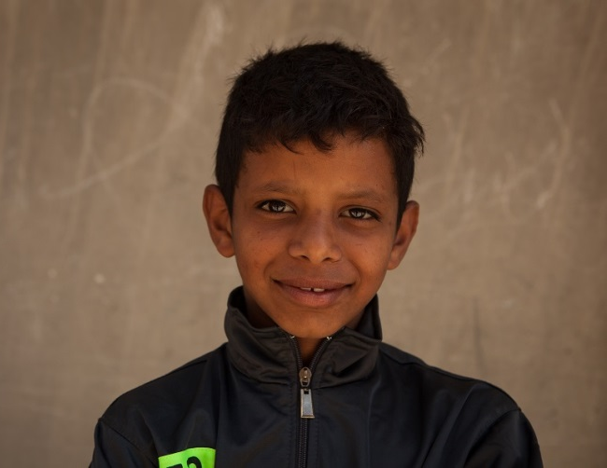
Jordan is on the frontlines of the Syrian exodus. The refugee camps are overcrowded and the schools run in shifts, with a morning and evening session. Nearly 3 million Syrian children are out of school, according to Save the Children. Even in the camps, many children are unable to access schooling.
Ms McGrath said most children in the camps had lost about three years of schooling, and were expected to lose more. “If you can imagine an Australian child losing six or seven years of school, you can imagine the impacts on the intellectual and social development of these children”.

McGrath noted the children she encountered in the camps in Jordan showed obvious signs of trauma, including fear of loud noises. Many of the children she met were distrustful, adding that the trauma would affect their ability to form positive relations with others.
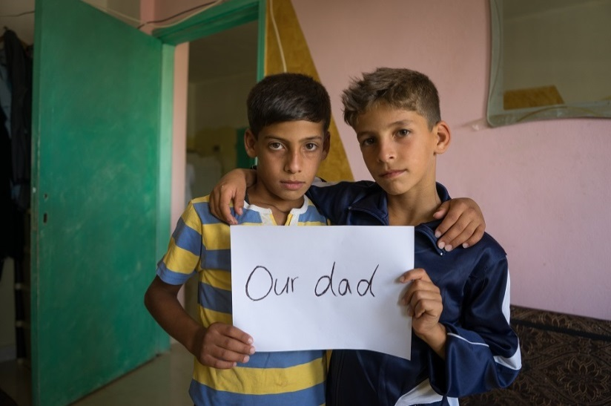
“If there were large noises in the camp, for instance a plane going overhead, the children would get very frightened and cower down as if a bomb was exploding” she said.
One pair of twins, who cannot be named for safety reasons, has not heard from their father in about three years. He stayed in Syria while the boys and their mother fled the country.
The boys fear their father was killed in conflict or arrested and executed for preventing their conscription to the Syrian army.
Ms McGrath said the photo of the boys served as a reminder of the simple things the conflict had taken away. “We asked the family to write down on piece of paper what the war had taken from them. The two young boys said 'Our dad'.
One woman, aged 26, the same age as Ms McGrath, told of the harrowing ordeal she experienced leaving the country.
Walking for over two weeks, much of the time in circles to avoid running into the army or militants, she saw people killed before her own eyes.
"On the last day of the journey, [the woman's] youngest sister, who was eight months pregnant, had a miscarriage just because of the physical and psychological trauma of the journey," Ms McGrath said.
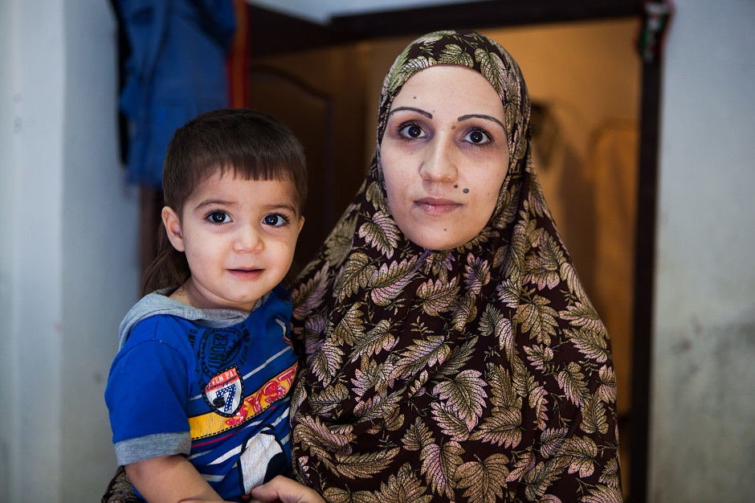
As a sister, as a woman and a person, I cannot even imagine having to watch a family member go through that.
Ms McGrath said the support of the international community had been warmly felt by the refugees.
"They don't just need emotional support, they need food aid, access to water, health and education," she said.
"The thing is, there is no end in sight for this conflict, so those needs will continue into the future. Australians need to keep the Syrians in their mind, even if they are not in the news anymore. Whenever we asked refugees if they'd like to send a message to Australians, they would say, 'We thank you from the bottom of our heart”.
All photos: Karen McGrath, Act for Peace
Safe Church Program update
The NCCA Safe Church Program continues to evolve within the dynamic scope of safeguarding children and vulnerable adults in church contexts. It is establishing itself as a peak body assisting churches in training and resources, and continues to engage with government and non-government agencies to further develop ideas and share resources.
One such development is looking into how churches can respond to the area of Domestic/Family Violence that is prevalent in our country. For churches to be a safe place for support, healing and guidance, we want to be able to equip churches by empowering them with the skills and resources to be that safe place.
Cameron Haig, the National Coordinator of the Safe Church Program has also recently connected with the World Council of Churches (WCC) in relation to how they are developing child-friendly churches. Cameron will continue to engage with The Special Advisor for Child Rights, Frederique Seidel, to enable the NCCA and the WCC to work together in developing these tools.
The Safe Church Training Agreement (SCTA) continues to build its training resources with the 2015 revised Framework and Standards developed earlier in the year and we are making good progress on the NCCA Safe Church training manual, workbook and presentation package.
If you would like to learn more Safe Church tips or to be placed on our mailing list so you can receive updates about the Safe Church Program please contact us by email: scta@ncca.org.auor visit our website: www.safechurches.org.au
A Safe Church Tip
A disclosure is any information given that may indicate a risk of harm to child, past or present and that there has been a likelihood of abuse taken place, or that the chid may be at risk of abuse.

Listening to disclosures of abuse is never an easy thing to do, when responding to these disclosures keep in mind the 3 “Rs”… Reassure, Record and Report.
INTERFAITH
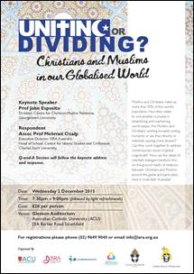
This public talk by Professor John Esposito, a leading international scholar and speaker on Islam and Christian-Muslim relations in the English speaking world, could be of interest for teachers, students, studies of religion, catechists, priests, pastoral associates, interfaith activists and concerned citizens.
EVENTS
UN Climate Change Conference
From 30 November to 11 December world leaders will gather in Paris at the crucial United Nations Climate Change Conference (COP 21). Faith-based groups around the world are building awareness of the importance of reaching a binding and ambitious agreement at the talks through prayer and action. http://www.oikoumene.org/en/press-centre/news/hundreds-of-pilgrims-making-way-to-un-climate-change-conference
People's Climate March Australia - November 27-29
On the last weekend of November, in the lead up to COP 21, Australians are invited to gather in their nearest city and march along with millions of people in hundreds of major cities around the world. Consider taking this small step to bring about change in renewable energy, for secure job creation, for clean air, for a healthy environment and a safe climate. http://www.peoplesclimate.org.au/
November | 27-29
  People’s Climate March Australia
 | 27 | First Sunday of Advent (Western Christian)
December | 3 | International Day of Persons with Disabilities
 | 10 | UN Human Rights Day: 10 December
 | 25 | Christmas Day - Nativity of the Christ (Western Christian)

